**Grant Levang LVNGR001**

**Portfolio Theory Assignment 2: Risk and Portfolio construction**

Introduction:

The shares which I have selected to answer the questions in this assignment formed part of the JSE Top40 as at February 29, 2016. The reason for this selection is that monthly data of shares from this category were easily available to me. With regards to the groupings of these shares, I randomly selected 20 shares from this Top40 category and from those 20 shares, I randomly chose 10 shares to make up group 1. The remaining 10 shares comprised group 2.

Selected shares:

|  |  |
| --- | --- |
| Group 1: | AGL, BAT, CCO, FFB, INL, MNP, NED, NTC, OML and WHL. |
| Group 2: | APN, BGA, BVT, CFR, FFA, FSR, REI, REM, RMH and SHP. |

Question 1:

|  |  |  |  |  |  |  |  |
| --- | --- | --- | --- | --- | --- | --- | --- |
| Group | Share | 3-year return | Beta | Reliability of beta | R squared | Unique Risk | Annualized standard deviation |
| 1 | **AGL** | -62.897% | 1.59 | 0.240143 | 0.00018 | 0.00553 | 0.36638 |
| **BAT** | 393.789% | 0.59 | 0.295883 | 0.01251 | 0.00652 | 0.29579 |
| **CCO** | 116.709% | 0.13 | 0.207855 | 0.00077 | 0.00355 | 0.20769 |
| **FFB** | 353.947% | -0.23 | 0.341638 | 0.02939 | 0.00909 | 0.33228 |
| **INL** | 65.521% | 0.98 | 0.149939 | 0.02224 | 0.00398 | 0.27106 |
| **MNP** | 152.353% | 1.22 | 0.225735 | 0.00347 | 0.00704 | 0.35280 |
| **NED** | 3.534% | 0.58 | 0.157524 | 0.01010 | 0.00370 | 0.23083 |
| **NTC** | 72.150% | 0.63 | 0.163142 | 0.00138 | 0.00356 | 0.23074 |
| **OML** | 42.679% | 1.05 | 0.169998 | 0.04053 | 0.00343 | 0.26607 |
| **WHL** | 37.098% | 0.68 | 0.209368 | 0.01272 | 0.00443 | 0.25619 |
| 2 | **APN** | 68.090% | 0.49 | 0.226185 | 0.01267 | 0.00585 | 0.27664 |
| **BGA** | -3.114% | 0.67 | 0.170747 | 0.00702 | 0.00347 | 0.23152 |
| **BVT** | 52.935% | 0.66 | 0.139915 | 0.02056 | 0.00230 | 0.19814 |
| **CFR** | 41.765% | 1.00 | 0.222592 | 0.00116 | 0.00482 | 0.29122 |
| **FFA** | -1.974% | 0.06 | 0.136783 | 0.00094 | 0.00137 | 0.12859 |
| **FSR** | 54.198% | 0.74 | 0.161354 | 0.00018 | 0.00360 | 0.24080 |
| **REI** | 89.235% | 0.41 | 0.155231 | 0.00493 | 0.00303 | 0.20222 |
| **REM** | 45.982% | 0.53 | 0.120261 | 0.00103 | 0.00150 | 0.15968 |
| **RMH** | 47.460% | 0.74 | 0.190513 | 0.00870 | 0.00362 | 0.24072 |
| **SHP** | -12.158% | 0.35 | 0.244265 | 0.01561 | 0.00488 | 0.24882 |

Question 2:

|  |  |  |
| --- | --- | --- |
|  | **Portfolio** | |
| **A** | **B** |
| **3 year return:** | 117.488% | 38.242% |
| **Beta:** | 0.62 | 0.57 |
| **Reliability of beta:** | 0.08124 | 0.08070 |
| **Annualized Standard deviation:** | 0.12772 | 0.12236 |
| **Annualized tracking error to ALSI:** | 0.25062 | 0.37197 |
| **Concentration:** | 0.1 | 0.1 |

Question 3:

|  |  |  |
| --- | --- | --- |
|  | **Portfolio** | |
| **A** | **B** |
| **3 year return:** | 66.315% | 41.201% |
| **Beta:** | 0.96 | 0.71 |
| **Reliability of beta:** | 0.09134 | 0.08423 |
| **Annualized Standard deviation:** | 0.16341 | 0.14639 |
| **Annualized tracking error to ALSI:** | 0.27004 | 0.37837 |
| **Concentration:** | 0.15262 | 0.16118 |

Comments:

* The return of portfolio A is much greater under equal weighting than under weighting them according to their market cap.
* The annualized standard deviation is less for both portfolio A and portfolio B under equally weighted share holdings.
* The annualized tracking error with the ALSI is lower for both portfolios when the weightings are equal.
* The returns are very high. This is due to the fact that we are focusing on a 3-year period which means there is a lot of time for share prices to rise (or fall).

Findings:

For my particular choice of shares, the statistics suggest that the equally weighted portfolios are less risky and follow the benchmark (ALSI) more closely. The fact that the equally weighted portfolios are less risky is consistent with the theory.

A clearer view (Question 5a continued):

Question 5b: **Equal Weighting**

The correlation coefficient for portfolio A and B using equally weighted share holdings was calculated to be $ρ=0.637012$.

The minimum variance portfolio combination (by analytical calculation) returned the following optimal weighting:

|  |  |
| --- | --- |
| Weight of investment in portfolio A: | 0.44 |
| Weight of investment in portfolio B: | 0.56 |

This combination gives a return of 73.11% over the 3-year period.

Please see appendix 1 for tabulated working of varying the investment proportions by 10% in the equally weighted portfolios.

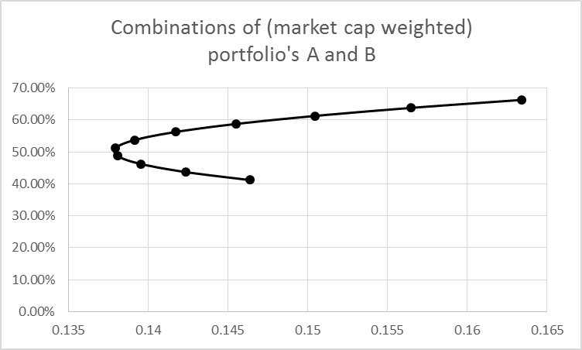A clearer view (Question 5c (a) continued):

Question 5c (b): **Market Cap Weighting**

The correlation coefficient for portfolio A and B using market cap weighted share holdings was calculated to be $ρ=0.613273$.

The minimum variance portfolio combination (by analytical calculation) returned the following optimal weighting:

|  |  |
| --- | --- |
| Weight of investment in portfolio A: | 0.36 |
| Weight of investment in portfolio B: | 0.64 |

This combination gives a return of 50.24% over the 3-year period.

Please see appendix 2 for tabulated working of varying the investment proportions by 10% in the market cap weighted portfolios.

Question 6d:

Comments and findings:

* The efficient frontier lies well above the four portfolios on the risk-return plane. Given that my share selection was random, I did not have expectations of any of the portfolios being efficient.
* The portfolios are provide much lower returns than the other portfolios along the efficient frontier for the same level of risk.
* The weightings of the 20 share universe in the optimal portfolio suggest that investing in only a specific 7 of the 20 shares was more efficient than investing in all of the shares.
* As we have seen earlier, the market cap weighted portfolios are riskier than the portfolios holding shares in equal weighting. The returns from the market cap weighted portfolios are also not better (on average) than the portfolios with equally weighted share holdings.
* The optimal portfolio has both a higher return and a lower risk than the four portfolios I have constructed.

**Appendices**

Appendix 1:

|  |  |  |  |
| --- | --- | --- | --- |
| Weight in A | Weight in B | Risk | Return |
| 100% | 0% | 0.127716 | 117.49% |
| 90% | 10% | 0.119406 | 109.56% |
| 80% | 20% | 0.112387 | 101.64% |
| 70% | 30% | 0.106914 | 93.71% |
| 60% | 40% | 0.103232 | 85.79% |
| 50% | 50% | 0.101536 | 77.87% |
| 40% | 60% | 0.101926 | 69.94% |
| 30% | 70% | 0.104378 | 62.02% |
| 20% | 80% | 0.108753 | 54.09% |
| 10% | 90% | 0.114832 | 46.17% |
| 0% | 100% | 0.12236 | 38.24% |

A and B in the table above refer to portfolios A and B. The table relates to the portfolios of equally weighted shares.

Appendix 2:

|  |  |  |  |
| --- | --- | --- | --- |
| Weight in A | Weight in B | Risk | Return |
| 100% | 0% | 0.163413 | 66.32% |
| 90% | 10% | 0.156477 | 63.80% |
| 80% | 20% | 0.150473 | 61.29% |
| 70% | 30% | 0.145516 | 58.78% |
| 60% | 40% | 0.141717 | 56.27% |
| 50% | 50% | 0.13917 | 53.76% |
| 40% | 60% | 0.137945 | 51.25% |
| 30% | 70% | 0.138076 | 48.74% |
| 20% | 80% | 0.13956 | 46.22% |
| 10% | 90% | 0.142355 | 43.71% |
| 0% | 100% | 0.146386 | 41.20% |

Again, A and B in the table above refer to portfolios A and B. The table relates to the portfolios of shares weighted according to the company’s market capitalisation.